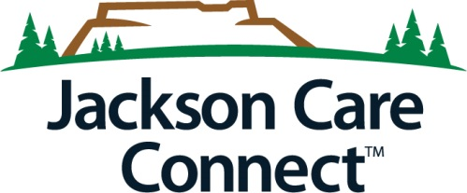
2021 SPONSORSHIP REQUEST FORM

Mission: Jackson Care Connect empowers people and systems to improve the health of our community.
Vision: Health, well-being, and equity for all people of Jackson County.

SPONSORSHIP PROCESS: Jackson Care Connect (JCC) welcomes sponsorship requests to support community efforts that align with our Mission, Vision, Values, and the Community Health Improvement Plan (CHIP) to serve Medicaid eligible (low-income) populations. Preference is given to sponsorships for direct service projects and programs. These requests will be considered up to $3000. Consideration will be given to sponsorship of one fundraising event per organization annually; however, such requests will be limited to 2,000. Please let us know how we can partner with your organization for the project or program as appropriate.

Sponsorship requests are reviewed quarterly. Please note the following deadlines, and submit your sponsorship request and W9 by: February 1, May 1, August 1, and November 1. We will review these request middle of the month and have a response for you by end of that quarter. It is most helpful to submit request at least 60 days in advance of your event.

Completed forms should be returned to: Michael Klein kleinm@careoregon.org

Organization Name (Check payable, must have matching W9): |  |  | Requested Amount:
Organization Mailing Address:

Contact Person Name, Email and Phone:

Event and/or Program Name:

Event/Program Purpose: (please attach any supplemental information such as flyers, agendas, etc.)

What specifically will these sponsorship funds be used for? What is the total cost of this program or event?

Is tabling an option at the event?  ☐Yes  ☐No | Event Date: | Anticipated number of people served?  If known, number of OHP members served?

SPONSORSHIP LEVELS:
The following are general guidelines to provide recognition to JCC for awarded support:
$1 - $999 Jackson Care Connect is recognized by name or logo.
$1,000 - $1,999 Jackson Care Connect logo is on all print materials and in a legible size.
$2,000 - $3,000 Jackson Care Connect is recognized as a primary sponsor with prominent logo
placement, mention in media, and social media.

PLEASE DESCRIBE WHICH AREA OF FOCUS YOUR PROJECT ALIGNS WITH (Check all that Apply):

☐Advancing Health Equity
☐Families and Youth

☐Housing/ Houseless Services

☐Behavioral Health
☐CHIP priorities

Health Equity: we are committed to supporting the development, spread and sustainability of Health Equity, Diversity and Inclusion programs that will help reduce health disparities and increase equitable health access for OHP members.
- How does your organization engage with diverse populations? How do you deliver services in an inclusive way?

- Does this event engage Jackson Care Connect members and/or low-income community members?

- Will information about the event, including at the event, be offered in languages other than English? (Please specify)

Outcomes – Please share anticipated measurable outcomes that will impact health: How would you measure/how will you know if you have impacted health outcomes to participants. How is this measured?

Please list any brand awareness and recognition opportunities JCC will receive for sponsoring this event:

Due date and requirements for ad copy, logo and supplemental material to be provided by JCC

For Internal Use
Total Amount Approved $__________________
Funding Source: Project Code:
Gainshare 600009 Sponsorship

